**Basic concepts of OOPs**

* Object
* Class
* Inheritance
* Polymorphism
* Abstraction
* Encapsulation

**Variables in Java**

* Local:- Variable declare inside a method
* Instance:- Variable declare inside a class but outside the method
* Static:- Variable that is declare as static. It cannot be local

**Data types in Java**

* Primitive
* Non primitive

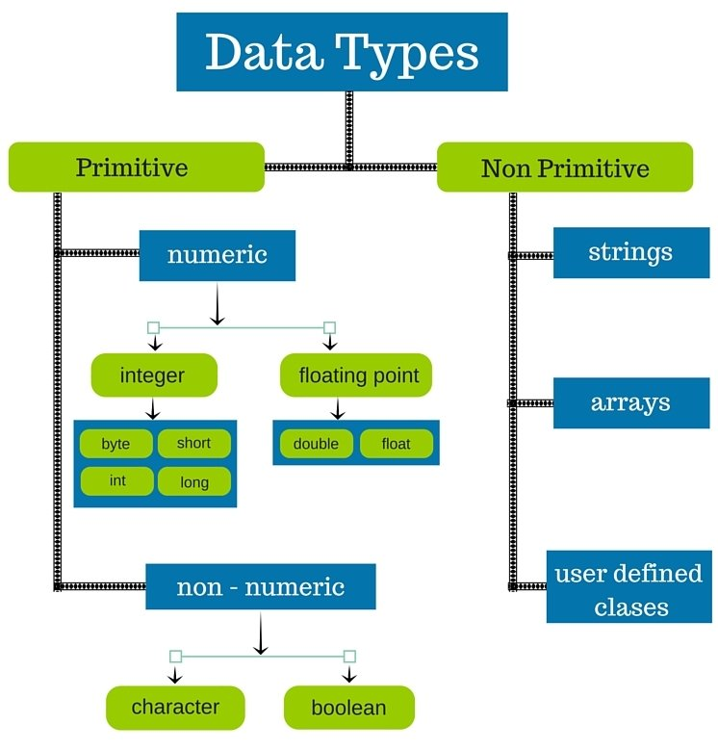

**Wrapper Class**

Wrapper class provide the mechanism to convert primitive to object and object to primitive.

Primitive Wrapper class

boolean Boolean

char Character

byte Byte

short Short

int Integer

long Long

float Float

double Double